
Home Page

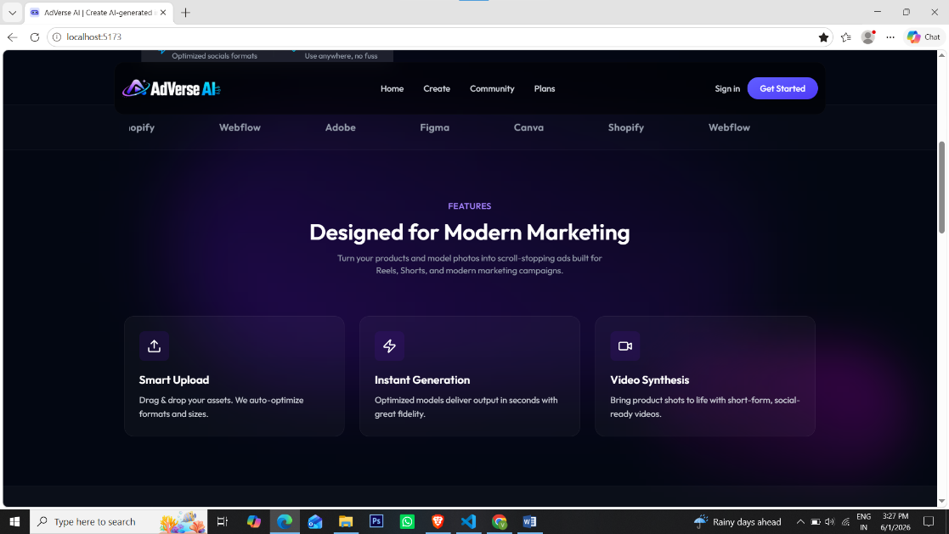

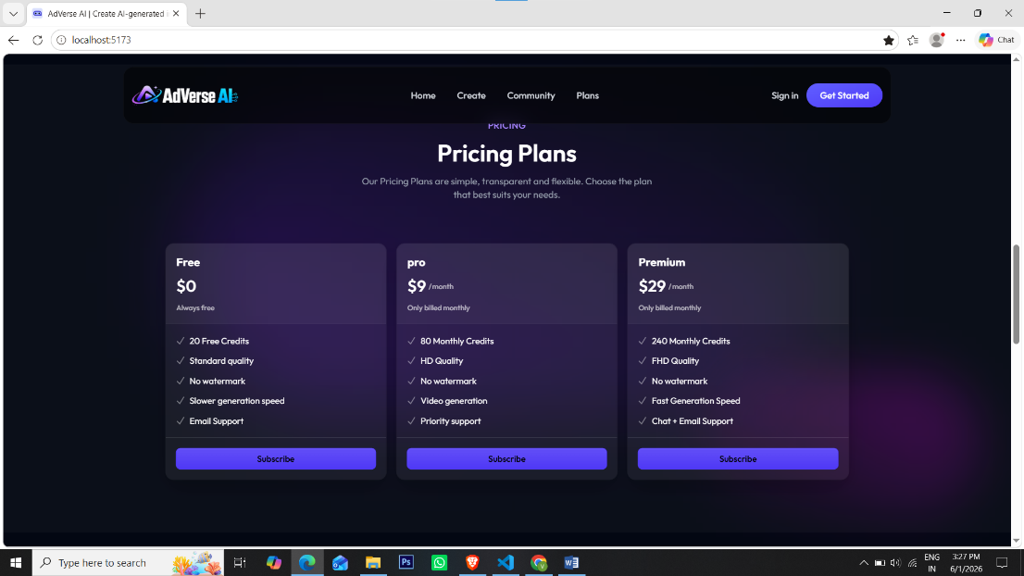

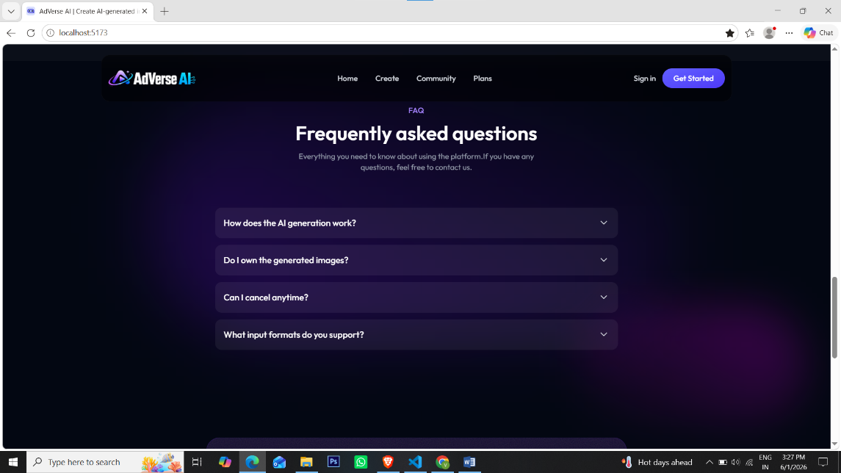

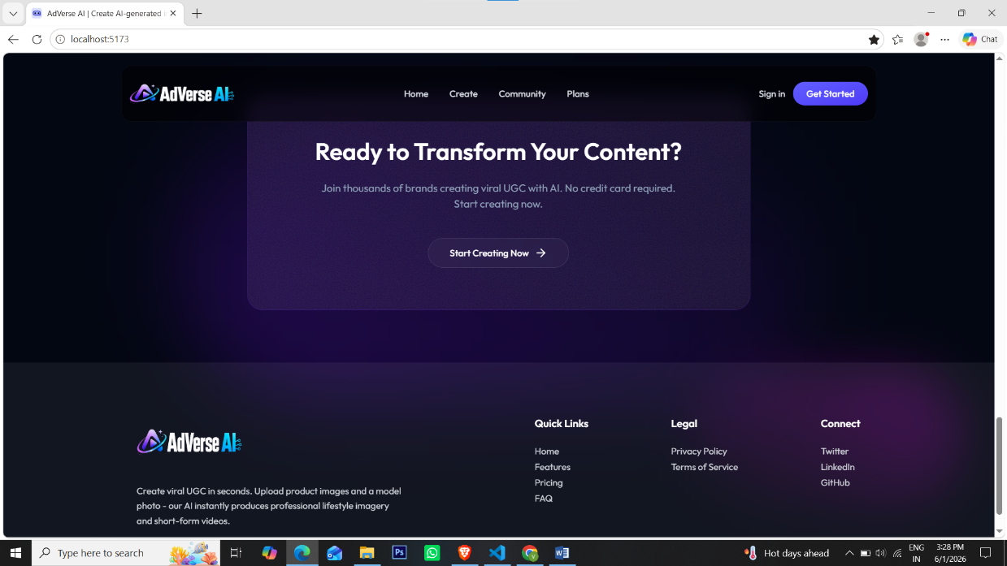

Code
import Hero from "../components/Hero";
import Features from "../components/Features";
import Pricing from "../components/Pricing";
import Faq from "../components/Faq";
import CTA from "../components/CTA";

export default function Home() {
return (
<>
<Hero />
<Features />
<Pricing />
<Faq />
<CTA />
</>
)
}

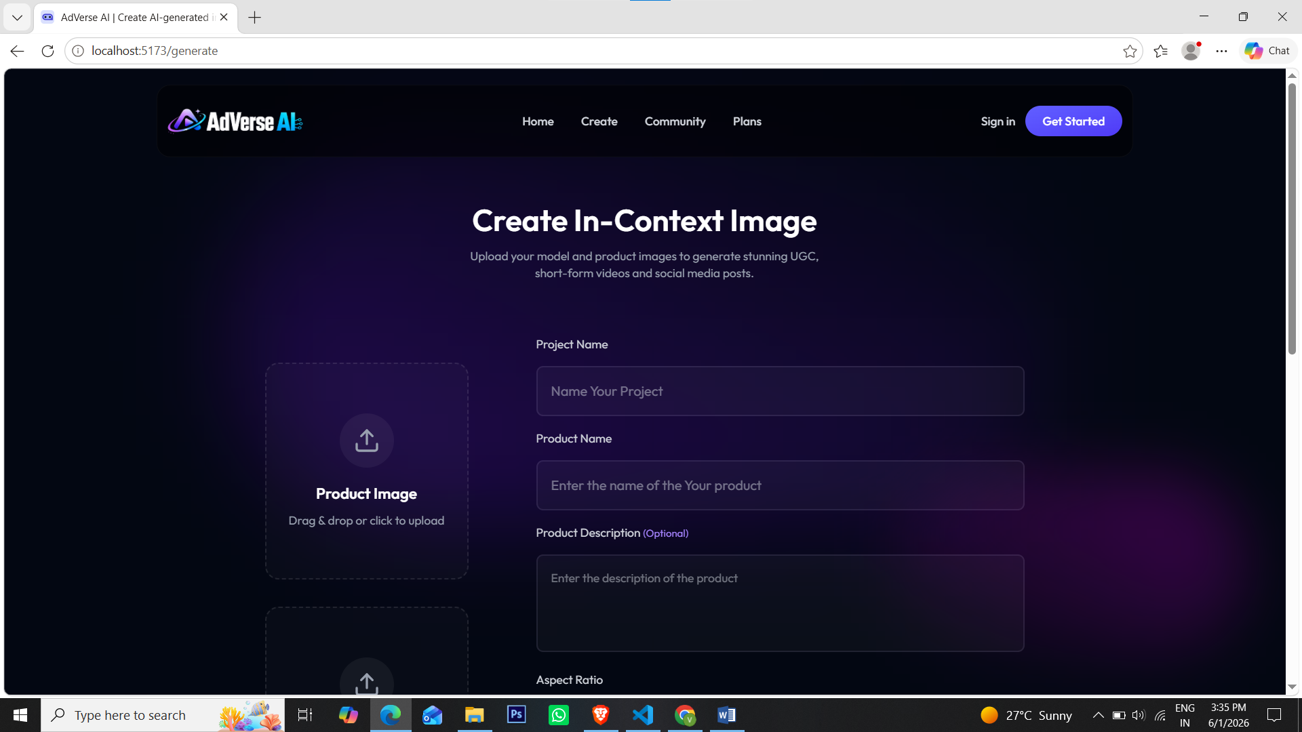
Create Page

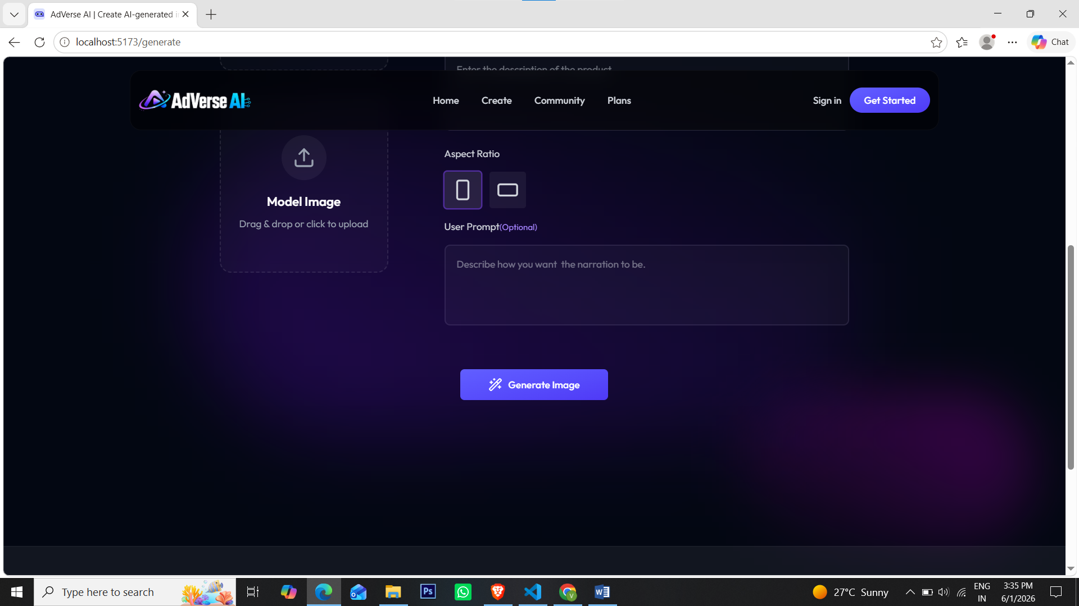

Code
import React, { useState } from "react";
import Title from "../components/Title";
import UploadZone from "../components/UploadZone";
import { Loader2Icon, RectangleHorizontalIcon, RectangleVerticalIcon, Wand2Icon } from "lucide-react";
import { PrimaryButton } from "../components/Buttons";

const Generator = () => {
const [name, setName] = useState("");
const [productName, setProductName] = useState("");
const [productDescription, setProductDescription] = useState("");
const [aspectRatio, setAspectRatio] = useState("9:16");
const [productImage, setProductImage] = useState<File | null>(null);
const [modelImage, setModelImage] = useState<File | null>(null);
const [UserPrompt, setUserPrompt] = useState("");
const [isGenerating, setIsGenerating] = useState(false);

const handleFileChange = (
e: React.ChangeEvent<HTMLInputElement>,
type: "product" | "model",
) => {
if (e.target.files && e.target.files[0]) {
if (type === "product") setProductImage(e.target.files[0]);
else setModelImage(e.target.files[0]);
}
};

const handleGenerate = async (e: React.FormEvent<HTMLFormElement>) => {
e.preventDefault();
};

return (
<div className="min-h-screen text-white p-6 mt-28 md:p-12">
<form onSubmit={handleGenerate} className="max-w-4xl mx-auto mb-40">
<Title
heading="Create In-Context Image"
description="Upload your model and product images to generate stunning UGC, short-form videos and social media posts."
/>

<div className="flex gap-20 max-sm:flex-col items-start justify-between">
<div className="flex flex-col w-full sm:max-w-60 gap-8 mt-8 mb-12">
<UploadZone
label="Product Image"
file={productImage}
onClear={() => setProductImage(null)}
onChange={(e) => handleFileChange(e, "product")}
/>

<UploadZone
label="Model Image"
file={modelImage}
onClear={() => setModelImage(null)}
onChange={(e) => handleFileChange(e, "model")}
/>
</div>

{/* Right Column */}
<div className="w-full">
<div className="mb-4 text-gray-300">
<label htmlFor="name" className="block text-sm mb-4">
Project Name
</label>
<input
type="text"
id="name"
value={name}
onChange={(e) => setName(e.target.value)}
placeholder="Name Your Project"
required
className="w-full border-2 bg-white/3 rounded-lg p-4 border-violet-200/10 focus:border-violet-500/50 outline-none transition-all"
/>
</div>
<div className="mb-4 text-gray-300">
<label htmlFor="productName" className="block text-sm mb-4">
Product Name
</label>
<input
type="text"
id="productName"
value={productName}
onChange={(e) => setProductName(e.target.value)}
placeholder="Enter the name of the Your product"
required
className="w-full border-2 bg-white/3 rounded-lg p-4 border-violet-200/10 focus:border-violet-500/50 outline-none transition-all"
/>
</div>
<div className="mb-4 text-gray-300">
<label
htmlFor="productDescription"
className="block text-sm mb-4"
>
Product Description{" "}
<span className="text-xs text-violet-400">(Optional)</span>
</label>
<textarea
id="productDescription"
rows={4}
value={productDescription}
onChange={(e) => setProductDescription(e.target.value)}
placeholder="Enter the description of the product"
className="w-full border-2 bg-white/3 rounded-lg p-4 text-sm border-violet-200/10 focus:border-violet-500/50 outline-none resize-none transition-all"
/>
</div>

<div className="mb-4 text-gray-300">
<label className="block text-sm mb-4">Aspect Ratio</label>
<div className="flex gap-3">
<RectangleVerticalIcon
onClick={() => setAspectRatio("9:16")}
className={`p-2.5 size-13 bg-white/6 rounded transition-all ring-2 ring-transparent cursor-pointer ${aspectRatio === "9:16" ? "ring-violet-500/50 bg-white/10" : ""}`}
/>
<RectangleHorizontalIcon
onClick={() => setAspectRatio("16:9")}
className={`p-2.5 size-13 bg-white/6 rounded transition-all ring-2 ring-transparent cursor-pointer ${aspectRatio === "16:9" ? "ring-violet-500/50 bg-white/10" : ""}`}
/>
</div>
</div>

<div className="mb-4 text-gray-300">
<label
htmlFor="userPrompt"
className="block text-sm mb-4"
>
User Prompt
<span className="text-xs text-violet-400">(Optional)</span>
</label>
<textarea
id="userPrompt"
rows={4}
value={UserPrompt}
onChange={(e) => setUserPrompt(e.target.value)}
placeholder="Describe how you want the narration to be."
className="w-full border-2 bg-white/3 rounded-lg p-4 text-sm border-violet-200/10 focus:border-violet-500/50 outline-none resize-none transition-all"
/>
</div>
</div>
</div>
<div className="flex justify-center mt-10">
<PrimaryButton disabled={isGenerating} className="px-10 py-3 rounded-md disabled:opacity-70 disabled:cursor-not-allowed">{isGenerating ? (<><Loader2Icon className="size-5 animate-spin"/>Genrating...</>) : (<><Wand2Icon className="size-5"/> Generate Image</>)}</PrimaryButton>
</div>
</form>
</div>
);
};
export default Generator;
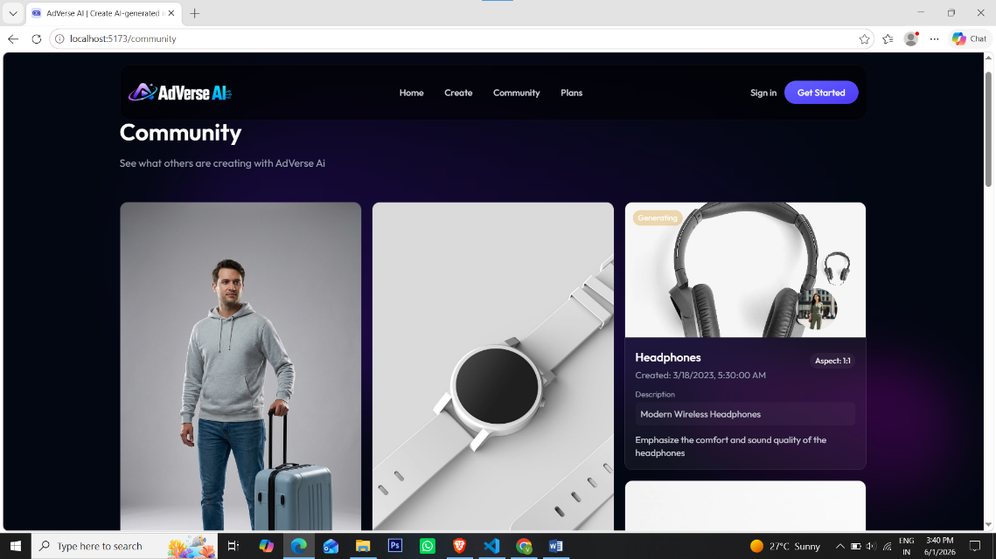
Community Page

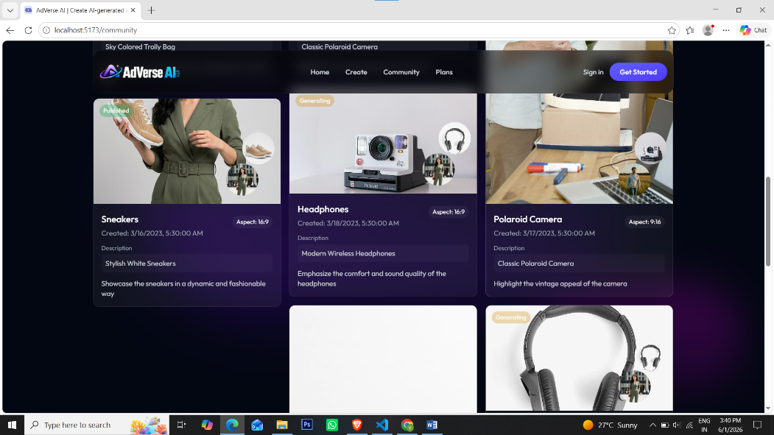
Code
import { useEffect, useState } from "react"
import type { Project } from "../types"
import { dummyGenerations } from "../assets/assets"
// import { div } from "framer-motion/client"
import { Loader2Icon } from "lucide-react"
import ProjectCard from "../components/ProjectCard"

const Community = () => {

const [projects, setProjects] = useState<Project[]>([])
const [loading, setLoading] = useState(true)

const fetchprojects = async () => {
setTimeout(() => {
setProjects(dummyGenerations);
setLoading(false)
},3000)
}

useEffect(() => {
fetchprojects()
},[])

return loading ? (
<div className="flex items-center justify-center min-h-screen">
<Loader2Icon className="size-7 animate-spin text-indigo-400"/>
</div>
) : (
<div className="min-h-screen text-white p-6 md:p-12 my-28">
<div className="max-w-6xl mx-auto">
<header className="mb-12">
<h1 className="text-3xl md:text-4xl font-semibold mb-4">Community</h1>
<p className="text-gray-400">See what others are creating with AdVerse Ai</p>
</header>
{/* Project list */}
<div className="columns-1 sm:columns-2 lg:columns-3 gap-4">
{projects.map((project) => (
<ProjectCard key={project.id} gen={project} setGenerations={setProjects} forCommunity={true}/>
))}

</div>
</div>
</div>
)
}

export default Community

Plans Page
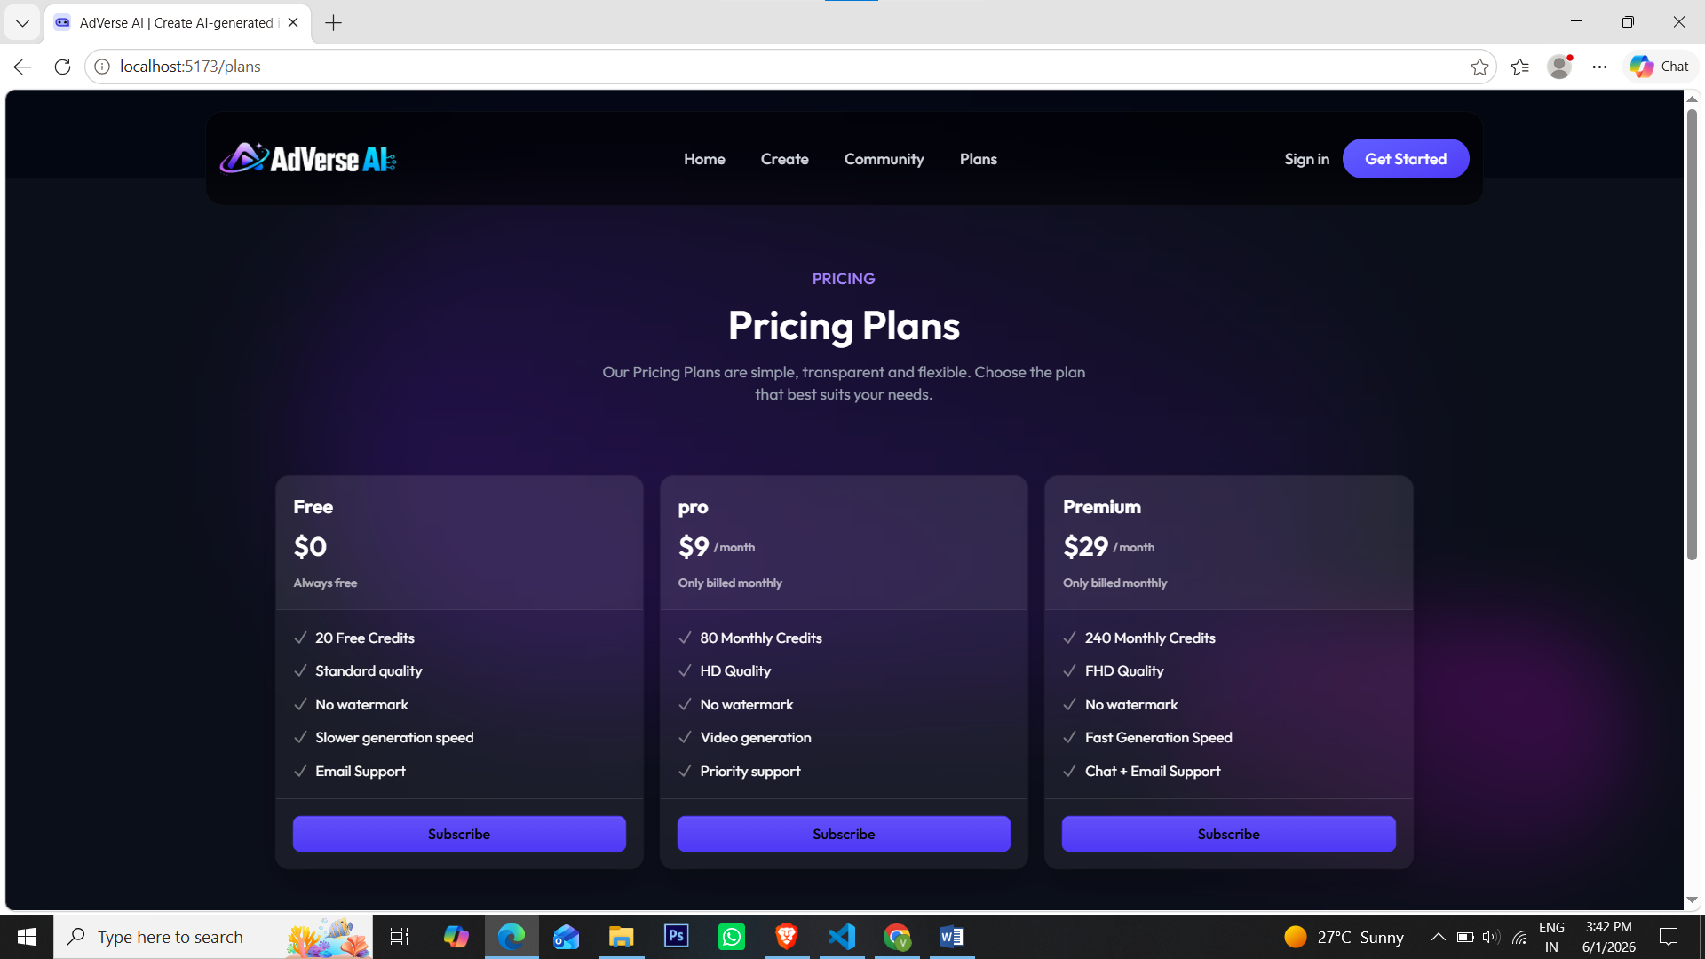
Code
import Pricing from "../components/Pricing"

const Plans = () => {
return (
<div className="max-sm:py-10 sm:pt-20">
<Pricing/>
<p className="text-center text-gray-400 max-w-md text-sm my-14 mx-auto px-12">Create stunning images for just <span className="text-indigo-400 font-medium">5 credits</span> and generate immersive videos for <span className="text-indigo-400 font-medium">10 credits</span> </p>
</div>
)
}

export default Plans
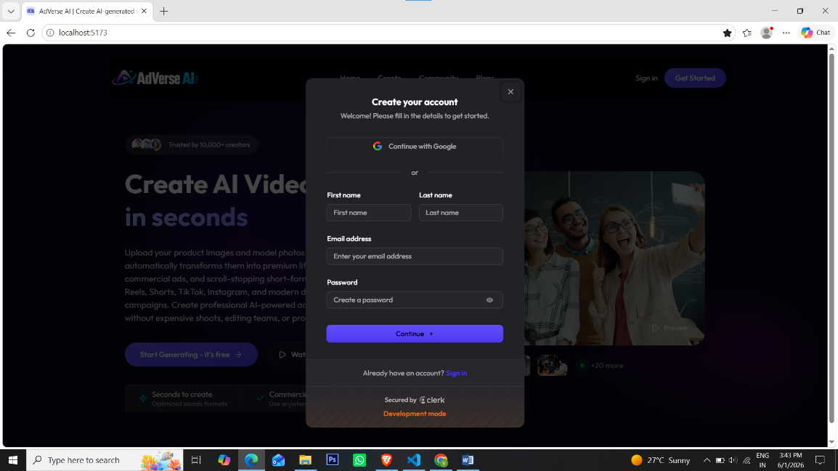
Login & sign up page

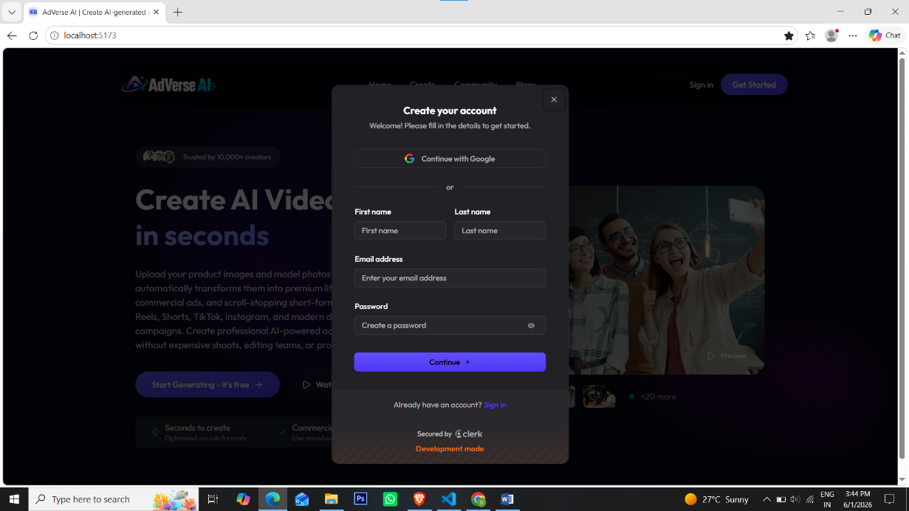

File Structure
AdVerse AI/
│
├── client/
│ │
│ ├── public/
│ │
│ ├── src/
│ │ │
│ │ ├── assets/
│ │ │
│ │ ├── components/
│ │ │ ├── Buttons.tsx
│ │ │ ├── CTA.tsx
│ │ │ ├── Faq.tsx
│ │ │ ├── Features.tsx
│ │ │ ├── Footer.tsx
│ │ │ ├── Hero.tsx
│ │ │ ├── Navbar.tsx
│ │ │ ├── Pricing.tsx
│ │ │ ├── ProjectCard.tsx
│ │ │ ├── SoftBackdrop.tsx
│ │ │ ├── Title.tsx
│ │ │ └── UploadZone.tsx
│ │ │
│ │ ├── pages/
│ │ │ ├── Community.tsx
│ │ │ ├── Generator.tsx
│ │ │ ├── Home.tsx
│ │ │ ├── Loading.tsx
│ │ │ ├── MyGenerations.tsx
│ │ │ ├── Plans.tsx
│ │ │ └── Result.tsx
│ │ │
│ │ ├── types/
│ │ │
│ │ ├── App.tsx
│ │ ├── main.tsx
│ │ └── index.css
│ │
│ ├── .env
│ ├── package.json
│ ├── package-lock.json
│ ├── vite.config.ts
│ ├── tsconfig.json
│ ├── tsconfig.app.json
│ ├── tsconfig.node.json
│ ├── eslint.config.js
│ ├── index.html
│ └── README.md
│
│
├── server/
│ │
│ ├── configs/
│ │ ├── ai.ts
│ │ ├── multer.ts
│ │ └── prisma.ts
│ │
│ ├── controllers/
│ │ ├── clerk.ts
│ │ ├── projectController.ts
│ │ └── userController.ts
│ │
│ ├── middlewares/
│ │ └── auth.ts
│ │
│ ├── routes/
│ │ ├── projectRoutes.ts
│ │ └── userRoutes.ts
│ │
│ ├── prisma/
│ │
│ ├── generated/
│ │ └── prisma/
│ │ └── models.ts
│ │
│ ├── types/
│ │ └── express.d.ts
│ │
│ ├── .env
│ ├── server.ts
│ ├── prisma.config.ts
│ ├── tsconfig.json
│ ├── package.json
│ └── package-lock.json
│
│
└── README.md

